Computer Programming I — Homework Assignment #12

Problem: Design a UNI Air Domestic Flights Booking System

Functions:
- Booking (訂票): Insert a new record into the binary file Reservations.dat. Any passenger cannot book twice the same flight on the same day.
- Booking inquiry (訂票紀錄查詢): Input an ID number, then display the reservation information of the passenger.
- Refund application (刪除訂票資料): Delete a record from the binary file Reservations.dat.

Requirements:
1. Global variables, except airportName , fullFare , discount and maxNumReservations, are not allowed.

Remark: The flightNo is unique in each flight.

The file record format of the file Reservations.dat:
char flightNo[ 8 ]; // Flight number
char id[ 12 ]; // ID number
char name[ 8 ]; // Name
char mobile[ 12 ]; // Mobile phone number
char date[ 12 ]; // Departure date
int tickets[ 8 ];
// tickets[ 0 ]: not used
// tickets[ 1 ]: number of full fare tickets
// tickets[ 2 ]: number of child tickets
// tickets[ 3 ]: number of infant tickets
// tickets[ 4 ]: number of senior citizen tickets
// tickets[ 5 ]: number of impaired tickets
// tickets[ 6 ]: number of impaired companion tickets
// tickets[ 7 ]: number of military tickets

The file record format of the file Flight Schedule.dat:
char flightNo[ 8 ]; // Flight number
int departureAirport; // Departure airport code
int arrivalAirport; // Arrival airport code
char departureTime[ 8 ]; // Departure time
char arrivalTime[ 8 ]; // Arrival time

The screen dialog should appear as follows:
Welcome to UNI Air Domestic Flights Booking System

Input your choice:
1. Booking
2. Booking inquiry
3. Refund application
4. End
? 2

Enter ID number: 999

No reservations! displayed in bookingInquiry

Input your choice:
1. Booking
2. Booking inquiry
3. Refund application
4. End
? 3

Enter ID number: 999

No reservations! displayed in bookingInquiry

Input your choice:
1. Booking
2. Booking inquiry
3. Refund application
4. End
? 1

Departure airport: displayed in booking
1. Taipei
2. Taichung
3. Chiayi
4. Tainan
5. Kaohsiung
6. Hualien
7. Taitung
8. Penghu
9. Kinmen
10. Beigan
11. Nangan
? 0

Departure airport:
1. Taipei
2. Taichung
3. Chiayi
4. Tainan
5. Kaohsiung
6. Hualien
7. Taitung
8. Penghu
9. Kinmen
10. Beigan
11. Nangan
? 12

Departure airport:
1. Taipei
2. Taichung
3. Chiayi
4. Tainan
5. Kaohsiung
6. Hualien
7. Taitung
8. Penghu
9. Kinmen
10. Beigan
11. Nangan
? 2

Arrival airport: displayed in chooseArrivalAirport
8. Penghu
9. Kinmen
11. Nangan
? 7

Arrival airport:
8. Penghu
9. Kinmen
11. Nangan
? 10

Arrival airport:
8. Penghu
9. Kinmen
11. Nangan
? 12

Arrival airport:
8. Penghu
9. Kinmen
11. Nangan
? 8

Departure date (yyyy/mm/dd): 2025/12/08 displayed in booking

Taichung to Penghu / Depart date: 2025/12/08.

Flight Departure Arrival Fare
8631 08:30 09:15 1769
8635 11:30 12:15 1769
8639 15:10 15:55 1769
8651 18:00 18:45 1769

Flight number: 8632 displayed in chooseFlight

Flight number: 8631

Number of infant tickets (0 ~ 4): 4

Number of full fare tickets (0 ~ 4): 2

Number of child tickets (0 ~ 4): 5

Number of senior citizen tickets (0 ~ 4): 0

Number of impaired tickets (0 ~ 4): 0

Number of impaired companion tickets (0 ~ 4): 0

Number of military tickets (0 ~ 4): 0

This booking system accepts a maximum of 4 passengers( including children ) per booking.
If there are more than 4 passengers, please make multiple bookings.

Number of full fare tickets (0 ~ 4): 2

Number of child tickets (0 ~ 4): 2

Number of senior citizen tickets (0 ~ 4): 0

Number of impaired tickets (0 ~ 4): 0

Number of impaired companion tickets (0 ~ 4): 0

Number of military tickets (0 ~ 4): 0

Each infant must always be accompanied by at least one adult.

Number of full fare tickets (0 ~ 4): 0

Number of child tickets (0 ~ 4): 0

Number of senior citizen tickets (0 ~ 4): 1

Number of impaired tickets (0 ~ 4): 1

Number of impaired companion tickets (0 ~ 4): 1

Number of military tickets (0 ~ 4): 1

Ticket information: displayed in displayReservations

Date: 2025/12/08
Flight: B7-8631

Taichung -> Penghu
08:30 09:15

Infant Fare TWD 0 x 4
Senior Citizen Fare TWD 884 x 1
Impaired Fare TWD 884 x 1
Impaired Companion Fare TWD 884 x 1
Military Fare TWD 1680 x 1

Total: 4332

ID number: 999

Name: 999

Mobile: 999

Booking completed!

Input your choice:
1. Booking
2. Booking inquiry
3. Refund application
4. End
? 2

Enter ID number: 999

displayed in bookingInquiry
1. Ticket information: displayed in displayReservations

Date: 2025/12/08
Flight: B7-8631

Taichung -> Penghu
08:30 09:15

Infant Fare TWD 0 x 4
Senior Citizen Fare TWD 884 x 1
Impaired Fare TWD 884 x 1
Impaired Companion Fare TWD 884 x 1
Military Fare TWD 1680 x 1

Total: 4332

Input your choice:
1. Booking
2. Booking inquiry
3. Refund application
4. End
? 2

Enter ID number: 888

No reservations! displayed in bookingInquiry

Input your choice:
1. Booking
2. Booking inquiry
3. Refund application
4. End
? 1

Departure airport: displayed in booking
1. Taipei
2. Taichung
3. Chiayi
4. Tainan
5. Kaohsiung
6. Hualien
7. Taitung
8. Penghu
9. Kinmen
10. Beigan
11. Nangan
? 8

Arrival airport: displayed in chooseArrivalAirport
1. Taipei
2. Taichung
3. Chiayi
4. Tainan
5. Kaohsiung
9. Kinmen
? 6

Arrival airport:
1. Taipei
2. Taichung
3. Chiayi
4. Tainan
5. Kaohsiung
9. Kinmen
? 2

Departure date (yyyy/mm/dd): 2025/12/09

Penghu to Taichung / Depart date: 2025/12/09.

Flight Departure Arrival Fare
8632 10:00 10:40 1769
8636 13:00 13:40 1769
8640 16:30 17:10 1769
8652 19:20 20:00 1769

Flight number: 8640

Number of infant tickets (0 ~ 4): 1

Number of full fare tickets (0 ~ 4): 1

Number of child tickets (0 ~ 4): 2

Number of senior citizen tickets (0 ~ 4): 1

Number of impaired tickets (0 ~ 4): 0

Number of impaired companion tickets (0 ~ 4): 0

Number of military tickets (0 ~ 4): 0

Ticket information:

Date: 2025/12/09
Flight: B7-8640

Penghu -> Taichung
16:30 17:10

Full Fare TWD 1769 x 1
Child Fare TWD 1326 x 2
Infant Fare TWD 0 x 1
Senior Citizen Fare TWD 884 x 1

Total: 5305

ID number: 999

Name: 999

Mobile: 999

Booking completed!

Input your choice:
1. Booking
2. Booking inquiry
3. Refund application
4. End
? 2

Enter ID number: 999

displayed in bookingInquiry
1. Ticket information: displayed in displayReservations

Date: 2025/12/08
Flight: B7-8631

Taichung -> Penghu
08:30 09:15

Infant Fare TWD 0 x 4
Senior Citizen Fare TWD 884 x 1
Impaired Fare TWD 884 x 1
Impaired Companion Fare TWD 884 x 1
Military Fare TWD 1680 x 1

Total: 4332

displayed in bookingInquiry
2. Ticket information: displayed in displayReservations

Date: 2025/12/09
Flight: B7-8640

Penghu -> Taichung
16:30 17:10

Full Fare TWD 1769 x 1
Child Fare TWD 1326 x 2
Infant Fare TWD 0 x 1
Senior Citizen Fare TWD 884 x 1

Total: 5305

Input your choice:
1. Booking
2. Booking inquiry
3. Refund application
4. End
? 3

Enter ID number: 888 displayed in refundApplication

No reservations! displayed in bookingInquiry

Input your choice:
1. Booking
2. Booking inquiry
3. Refund application
4. End
? 3

Enter ID number: 999

1. Ticket information:

Date: 2025/12/08
Flight: B7-8631

Taichung -> Penghu
08:30 09:15

Infant Fare TWD 0 x 4
Senior Citizen Fare TWD 884 x 1
Impaired Fare TWD 884 x 1
Impaired Companion Fare TWD 884 x 1
Military Fare TWD 1680 x 1

Total: 4332

2. Ticket information:

Date: 2025/12/09
Flight: B7-8640

Penghu -> Taichung
16:30 17:10

Full Fare TWD 1769 x 1
Child Fare TWD 1326 x 2
Infant Fare TWD 0 x 1
Senior Citizen Fare TWD 884 x 1

Total: 5305

Enter your choice: 1 displayed in refundApplication

The seleted booking has been deleted.

Input your choice:
1. Booking
2. Booking inquiry
3. Refund application
4. End
? 2

Enter ID number: 999

1. Ticket information:

Date: 2025/12/09
Flight: B7-8640

Penghu -> Taichung
16:30 17:10

Full Fare TWD 1769 x 1
Child Fare TWD 1326 x 2
Infant Fare TWD 0 x 1
Senior Citizen Fare TWD 884 x 1

Total: 5305

Input your choice:
1. Booking
2. Booking inquiry
3. Refund application
4. End
? 4

Welcome to UNI Air Domestic Flights Booking System

Input your choice:
1. Booking
2. Booking inquiry
3. Refund application
4. End
? 2

Enter ID number: 999

1. Ticket information:

Date: 2025/12/09
Flight: B7-8640

Penghu -> Taichung
16:30 17:10

Full Fare TWD 1769 x 1
Child Fare TWD 1326 x 2
Infant Fare TWD 0 x 1
Senior Citizen Fare TWD 884 x 1

Total: 5305

Input your choice:
1. Booking
2. Booking inquiry
3. Refund application
4. End
? 4

Call Graph

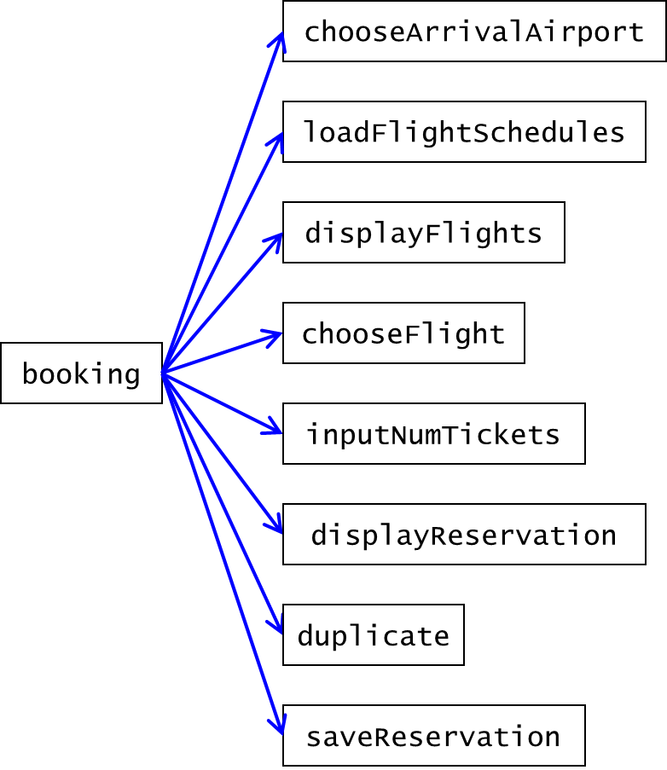

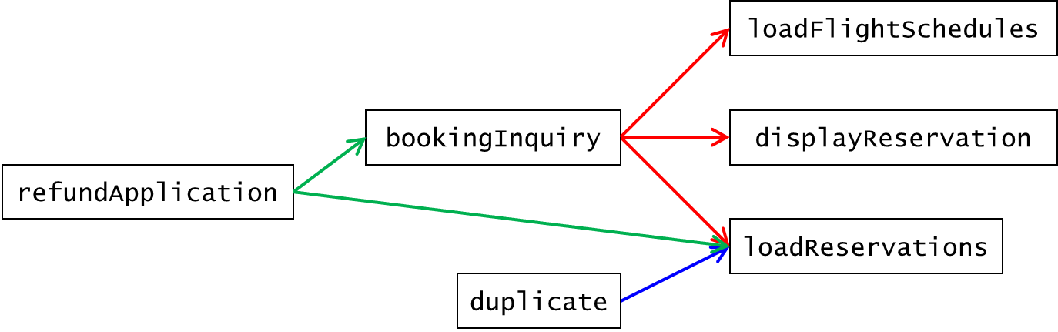

Airport code
Code | Airport | 機場
1 | Taipei | 臺北
2 | Taichung | 臺中
3 | Chiayi | 嘉義
4 | Tainan | 臺南
5 | Kaohsiung | 高雄
6 | Hualien | 花蓮
7 | Taitung | 臺東
8 | Penghu | 澎湖
9 | Kinmen | 金門
10 | Beigan | 北竿
11 | Nangan | 南竿

Full Fare
 | Taip | Taic | Chia | Tain | Kaoh | Hual | Tait | Peng | Kinm | Beig | Nang
Taipei | 0 | 0 | 0 | 0 | 0 | 1781 | 2460 | 2296 | 2618 | 2197 | 2197
Taichung | 0 | 0 | 0 | 0 | 0 | 0 | 0 | 1769 | 2236 | 0 | 2686
Chiayi | 0 | 0 | 0 | 0 | 0 | 0 | 0 | 1721 | 2217 | 0 | 0
Tainan | 0 | 0 | 0 | 0 | 0 | 0 | 0 | 1697 | 2231 | 0 | 0
Kaohsiung | 0 | 0 | 0 | 0 | 0 | 0 | 0 | 1876 | 2393 | 0 | 0
Hualien | 1781 | 0 | 0 | 0 | 0 | 0 | 0 | 0 | 0 | 0 | 0
Taitung | 2460 | 0 | 0 | 0 | 0 | 0 | 0 | 0 | 0 | 0 | 0
Penghu | 2296 | 1769 | 1721 | 1697 | 1876 | 0 | 0 | 0 | 1768 | 0 | 0
Kinmen | 2618 | 2236 | 2217 | 2231 | 2393 | 0 | 0 | 1768 | 0 | 0 | 0
Beigan | 2197 | 0 | 0 | 0 | 0 | 0 | 0 | 0 | 0 | 0 | 0
Nangan | 2197 | 2686 | 0 | 0 | 0 | 0 | 0 | 0 | 0 | 0 | 0

Flight Schedule.dat

Flight Number | Departure airport | Arrival airport | Departure time | Arrival time
8971 | 1 | 6 | 07:50 | 08:40
8977 | 1 | 6 | 19:00 | 19:50
8972 | 6 | 1 | 09:10 | 09:50
8978 | 6 | 1 | 20:20 | 21:00
8721 | 1 | 7 | 09:40 | 10:45
8725 | 1 | 7 | 13:30 | 14:35
8727 | 1 | 7 | 16:50 | 17:55
8729 | 1 | 7 | 18:45 | 19:50
8722 | 7 | 1 | 11:20 | 12:20
8726 | 7 | 1 | 15:10 | 16:10
8728 | 7 | 1 | 18:40 | 19:40
8730 | 7 | 1 | 20:30 | 21:30
8605 | 1 | 8 | 08:00 | 08:50
9105 | 1 | 8 | 10:30 | 11:30
8609 | 1 | 8 | 11:30 | 12:20
8615 | 1 | 8 | 15:40 | 16:30
8625 | 1 | 8 | 18:30 | 19:20
8606 | 8 | 1 | 09:50 | 10:40
8610 | 8 | 1 | 13:20 | 14:10
9106 | 8 | 1 | 15:40 | 16:35
8616 | 8 | 1 | 17:20 | 18:10
8626 | 8 | 1 | 20:10 | 21:00
8801 | 1 | 9 | 07:00 | 08:05
8809 | 1 | 9 | 09:00 | 10:20
9205 | 1 | 9 | 10:00 | 11:05
8811 | 1 | 9 | 10:45 | 11:50
8821 | 1 | 9 | 13:50 | 14:55
9207 | 1 | 9 | 15:00 | 16:05
8835 | 1 | 9 | 18:00 | 19:05
8802 | 9 | 1 | 08:55 | 09:55
9206 | 9 | 1 | 11:55 | 12:55
8812 | 9 | 1 | 12:40 | 13:40
8816 | 9 | 1 | 14:30 | 15:40
8822 | 9 | 1 | 15:50 | 16:50
9208 | 9 | 1 | 17:00 | 18:00
8836 | 9 | 1 | 20:10 | 21:10
8781 | 1 | 10 | 06:40 | 07:35
8789 | 1 | 10 | 15:20 | 16:15
8782 | 10 | 1 | 08:10 | 09:00
8790 | 10 | 1 | 16:50 | 17:40
8751 | 1 | 11 | 06:30 | 07:25
8755 | 1 | 11 | 09:30 | 10:25
8775 | 1 | 11 | 12:15 | 13:10
8759 | 1 | 11 | 13:05 | 14:00
8761 | 1 | 11 | 14:00 | 14:55
8767 | 1 | 11 | 16:00 | 16:55
8752 | 11 | 1 | 08:00 | 08:50
8756 | 11 | 1 | 11:25 | 12:15
8758 | 11 | 1 | 12:30 | 13:20
8760 | 11 | 1 | 13:45 | 14:35
8762 | 11 | 1 | 14:35 | 15:25
8768 | 11 | 1 | 17:30 | 18:20
8631 | 2 | 8 | 08:30 | 09:15
8635 | 2 | 8 | 11:30 | 12:15
8639 | 2 | 8 | 15:10 | 15:55
8651 | 2 | 8 | 18:00 | 18:45
8632 | 8 | 2 | 10:00 | 10:40
8636 | 8 | 2 | 13:00 | 13:40
8640 | 8 | 2 | 16:30 | 17:10
8652 | 8 | 2 | 19:20 | 20:00
8955 | 2 | 9 | 08:00 | 09:05
8957 | 2 | 9 | 11:20 | 12:25
8961 | 2 | 9 | 14:20 | 15:25
8965 | 2 | 9 | 17:35 | 18:40
8956 | 9 | 2 | 09:50 | 10:50
8960 | 9 | 2 | 13:30 | 14:30
8962 | 9 | 2 | 16:00 | 17:00
8966 | 9 | 2 | 19:30 | 20:30
8735 | 2 | 11 | 10:40 | 11:45
8736 | 11 | 2 | 15:40 | 16:45
8661 | 3 | 8 | 15:40 | 16:10
8662 | 8 | 3 | 14:30 | 15:00
8901 | 3 | 9 | 12:40 | 13:30
8902 | 9 | 3 | 11:00 | 11:55
8675 | 4 | 8 | 07:20 | 07:50
8681 | 4 | 8 | 13:10 | 13:40
8683 | 4 | 8 | 17:10 | 17:40
8676 | 8 | 4 | 08:35 | 09:10
8680 | 8 | 4 | 14:20 | 14:55
8682 | 8 | 4 | 15:50 | 16:25
8981 | 4 | 9 | 09:50 | 10:40
8991 | 4 | 9 | 15:40 | 16:30
8982 | 9 | 4 | 11:30 | 12:25
8992 | 9 | 4 | 17:10 | 18:05
8689 | 5 | 8 | 07:00 | 07:40
8691 | 5 | 8 | 08:00 | 08:40
8695 | 5 | 8 | 09:50 | 10:30
8697 | 5 | 8 | 10:50 | 11:30
8701 | 5 | 8 | 13:00 | 13:40
8707 | 5 | 8 | 14:30 | 15:10
8715 | 5 | 8 | 18:20 | 19:00
8690 | 8 | 5 | 08:20 | 09:00
8692 | 8 | 5 | 09:30 | 10:10
8696 | 8 | 5 | 11:10 | 11:50
8698 | 8 | 5 | 12:30 | 13:10
8710 | 8 | 5 | 16:50 | 17:30
8712 | 8 | 5 | 18:30 | 19:10
8716 | 8 | 5 | 19:30 | 20:10
8911 | 5 | 9 | 07:30 | 08:35
8917 | 5 | 9 | 11:10 | 12:00
8921 | 5 | 9 | 14:00 | 15:05
8927 | 5 | 9 | 17:30 | 18:35
8912 | 9 | 5 | 09:10 | 10:10
8918 | 9 | 5 | 13:10 | 14:00
8922 | 9 | 5 | 15:40 | 16:40
8928 | 9 | 5 | 19:20 | 20:20
8995 | 8 | 9 | 12:40 | 13:20
8996 | 9 | 8 | 14:05 | 14:50

